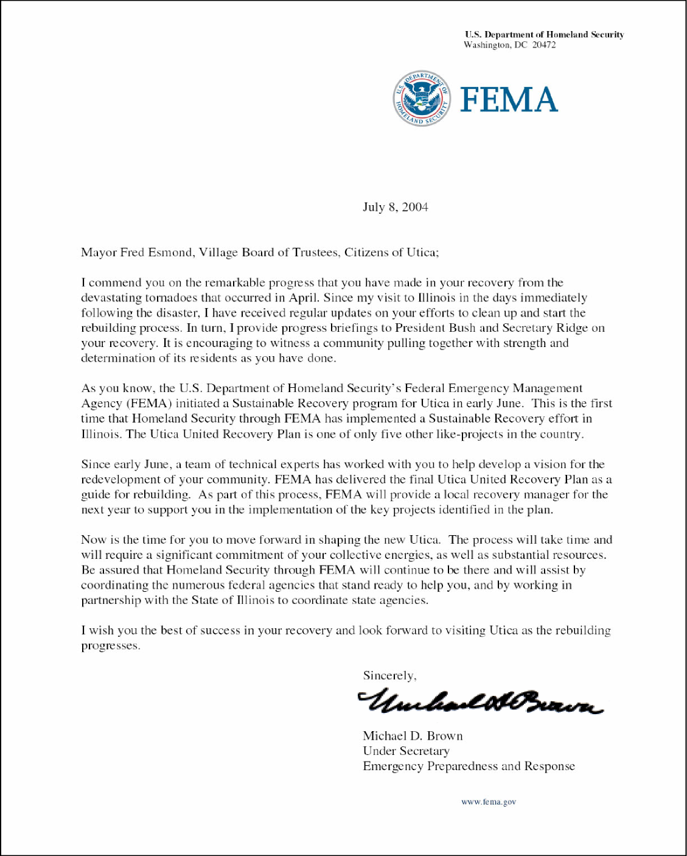
OFFICE OF THE GOVERNOR
SPRINGFIELD 62706

ROD BLAGOJEVICH
GOVERNOR
July 15, 2004 Mayor Esmond
Village Trustees
Township Trustees
Citizens of North Utica

Dear Local Officials and Citizens of North Utica:

It has been nearly three months since a devastating tornado struck the Village of Utica, severely disrupting the lives of the people who live and work there. At that time, the State of Illinois’ emergency response agencies moved swiftly to assist in rescue, debris removal, security, and restoration of essential services. Now the emergency clean-up effort is complete, but there still remains the long process of rebuilding and repairing businesses, homes and public property. I want to assure you that the State w continue to offer assistance as you work to recover and rebuild.

This rebuilding effort, while painful and difficult, does present some opportunities for the Village of Utica. Local officials are already considering the best way to approach a long-term recovery plan. T succeed, that plan must involve all levels of government, as well as local businesses, privat organizations and, most importantly, the citizens of Utica. Together, you have a great opportunity to develop a vision of your community’s future, and to create a comprehensive plan to make that vision a reality.

To help the Village develop the Utica United Recovery Plan, an Illinois Long-Term Recovery Team – representing the Illinois Department of Commerce and Economic Opportunity, Illinois Emergency Management Agency, Illinois Department of Transportation, Illinois Department of Natural Resources, Historic Preservation Agency and other agencies – is working closely with the Federal Emergency Management Agency

I strongly endorse this effort. I have directed the participating agencies to identify potential sources of funding to implement and complete projects proposed in the plan. I commend you and the citizens of Utica for the dedication and willingness you have demonstrated by working together through this difficult time, and I look forward to working with you as the long-term recovery effort gets under way.

Sincerely,
Rod Blagojevich Governor

