PHYSICALLY TIE UTICA TOGETHER FROM I-80 TO STARVED ROCK STATE PARK
Recovery Value
Tying the community together, both physically and visually, via an improved and connected pathway system would improve mobility for residents and visitors.
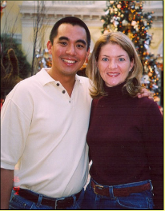
Goal
Use an interconnected series of pathways to enhance non-vehicular transportation throughout the community.
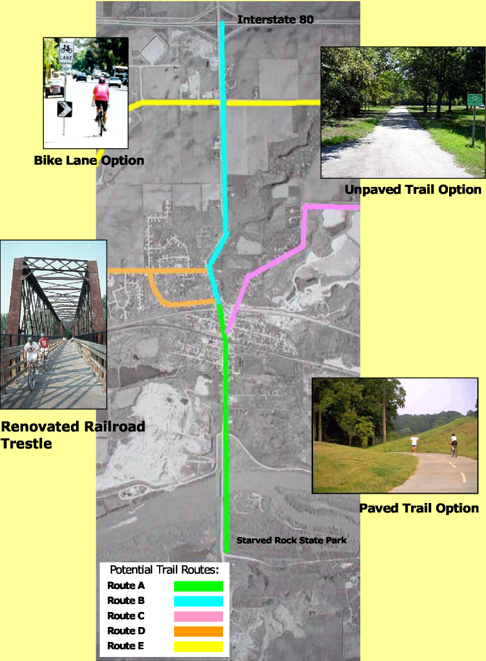
Rudy Pamintuan Michelle Rene Baert Entrepreneurs
Project Description
Extending bicycle and pedestrian paths from Starved Rock State Park through downtown Utica to I-80 will improve local connectivity and facilitate stronger links throughout Utica’s commercial corridor and Utica’s various residential areas such as Senica Manor, Ridgeview Estates, and Oak Bluff Estates. It would also facilitate visits by cyclists and other recreationists to the area, and improve the quality of life for all residents.
“Tying in the community with bike trails will encourage shoppers and visitors to downtown Utica and create an amenity within our community for more family activities.”
Options
Connected Pathway System
Utilize existing highways and streets to establish bicycle paths where sufficient shoulder widths are available for a bike lane or where sufficient right-of-way will allow for development of a separate bike path. Major new highway and street construction projects, such as the realignment of Illinois Route 178, should include dedicated bike lanes whenever possible. Depending upon funding availability, the lanes/paths can be either paved or unpaved.
Renovation of Railroad Trestle for Bike/Pedestrian path
An additional crossing over the I&M Canal would improve non-motorized transportation connectivity. Renovation of the existing railroad trestle west of the Mill Street bridge would connect the neighborhood to the south with the ballpark. In addition, this renovation would put a bridge of historic character back into functional use.
Cost  Routes | Miles | Bike Lane | Gravel Trail | Paved Trail
A | 2 | $105,600 | $158,400 | $316,800
B | 2 | $105,600 | $158,400 | $316,800
C | 1.75 | $92,400 | $138,600 | $277,200
D | 1.75 | $92,400 | $138,600 | $277,200
E | 2 | $105,600 | $158,400 | $316,800
Recovery Value
COMMUNITY INTEREST
*Cost of Trestle renovation to be determined after structural assessment

