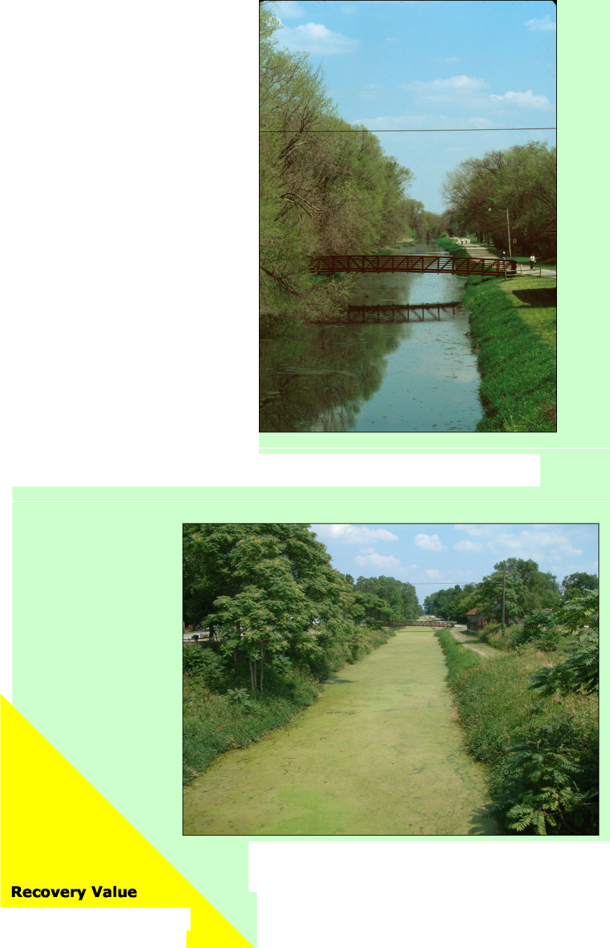

RESTORE / ENHANCE THE I&M CANAL
Recovery Value
Capitalizing on the significant tourism potential of the I&M Canal is very important to the revitalization of downtown Utica. In its current condition – stagnant and covered with algae – the canal detracts from the appeal of the downtown area. Flowing water in the canal would create an attractive local feature for the residents of Utica, and a catalyst for increased tourism and economic development for the community and the region.

Ana Koval President Canal Corridor Association
“Our focus right now is to strengthen the canal connection between LaSalle and Utica. Improvements on the Utica end are the key, particularly finding a way to restore the water flow.”
Restoring water flow to the Canal would maximize its potential as a tourist attraction and recreational feature
Stagnant water promotes algae growth in the summer months and reduces the appeal of the I&M Canal in Utica
MODERATE
Goal
Restore year-round flowing water to the I&M canal through provision of a consistent water source.

Project Description
Provide the Utica section of the I&M canal with a constant source of water using either the Clark Run Creek or the Illinois River.

Options
Install a Pump Station to bring water to the Canal from the Illinois River
Supplying water from the Illinois River would provide a constant flow of water into the canal. This project would require placement of a pumping station on the north bank of the Illinois River, and a pipeline from the mouth of Clark Run Creek to the Canal. In addition to the construction cost, annual operating costs would be incurred to support the pump station.

Construct gravity flow pipe to divert waters from Clark Run Creek to the I&M Canal
Water could be provided to the canal through the construction of an inlet structure on Clark Run Creek south of the railroad bridge. The inlet would be designed to maintain minimum base flow in the creek; however, this option may not provide adequate flow to the canal during the late summer and early fall months. In addition, the environmental impacts on Clark Run Creek and the potential effects of high velocity flow into the canal would require further study. Drainage easements for the placement of the pipeline may be required.

Planning Project: A Regional Approach
Many of the communities along the I&M Canal are interested in restoring the canal within their jurisdiction. If a regional approach can be implemented, it would increase the potential economic benefits to all communities along the canal. Currently the Canal Corridor Association and the U.S. Army Corps of Engineers are working toward a restoration project in nearby La Salle. A long-term goal of the Canal Corridor Association is to link Utica and La Salle to provide a continuous water feature to support tourism and recreation. A feasibility study could be completed to identify potential improvements and determine the needed steps for implementation.
Cost
Pump Station: $560,000 for construction, $30,000 for annual operating costs (16” diameter pipeline to supply 3,000 gpm of flow to canal)

Gravity Pipe: $240,000 for construction, no operating expense (24” pipe with 8,000 gpm capacity & associated inlet structure)

Planning Project: $100,000

