DEVELOP A MARKETING STRATEGY TO BETTER PROMOTE TOURISM
Recovery Value  Developing a marketing strategy, which when implemented in conjunction with appropriate signage, should lead to increased tourism in Utica, one of the Village’s primary economic drivers.  Goal  Strengthen the local economy by promoting existing Utica businesses, festivals, and area amenities, and understand how to take better advantage of the market potential of visitors to Starved Rock State Park. Encourage more/longer tourist visits and create new business opportunities for the area. Encourage travelers to visit with appealing signage and a recognizable vehicular “pathway”. | 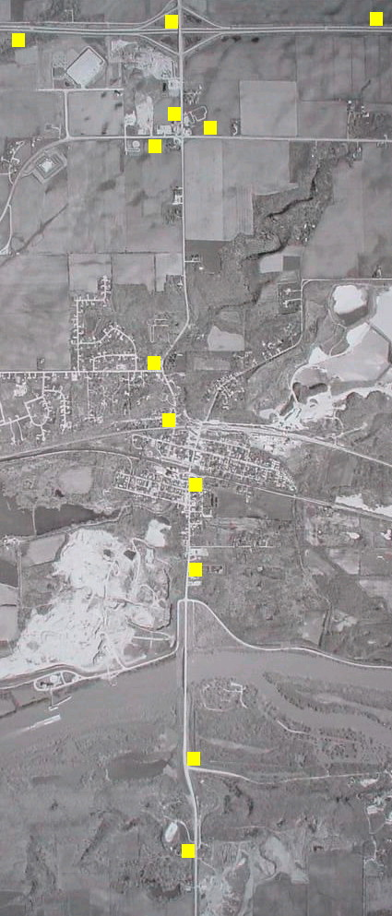                    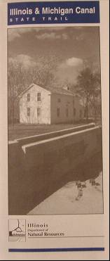  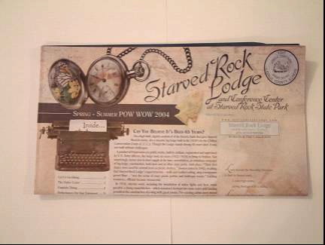  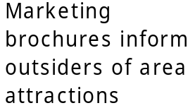 | 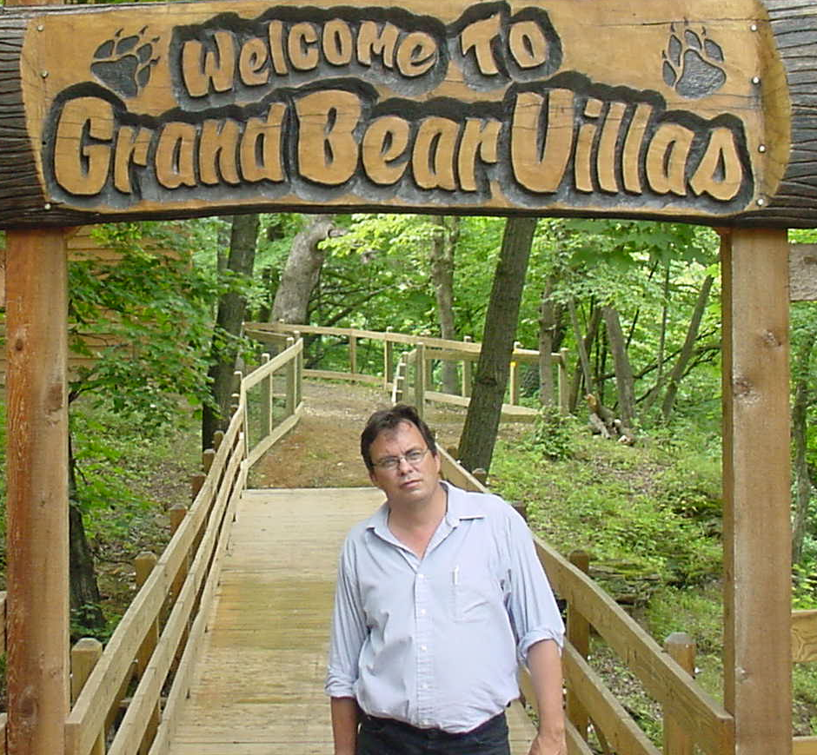  Joe Hook  Owner  Grand Bear Lodge  “Starved Rock State Park attracts 2.5 million visitors each year, most of which pass right through Utica. Let’s find a way to capitalize on our location, encourage longer stays, and provide more reasons to shop in the Village.”

Planning Strategies
MARKETING
Prepare a Local Marketing/Tourism Strategy
Establish Utica’s target markets (i.e. Chicago, recreationists, families, etc.), consistent Village selling points, and develop promotional strategies to attract additional business. Creating a community “brand” will also enable the Village to differentiate itself from its neighbors, position itself with its target market, and project a revitalized image to potential tourists.

Prepare a Regional Marketing Strategy
Work with regional partners, including Starved Rock State Park, to develop a regional marketing strategy that will cross-promote each community within it.

Establish a Village Website
Build an official Utica website to serve both residents navigating for Village services and tourists searching for travel destinations.

SIGNAGE
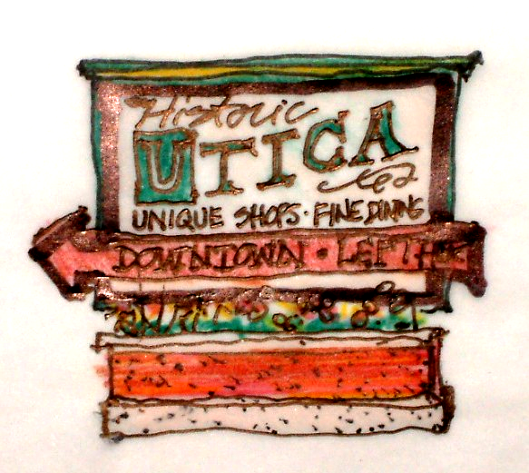

Consistent, appealing signage at strategic locations along I-80 and I-39 should promote increased visitor traffic to Utica. Signage along Illinois Route 178 would also direct tourists to Utica’s commercial corridor and other destinations within the community. Development of a commercial sign ordinance would promote a consistent community image. In addition, coordination with regional leaders to improve existing signage leading to Starved Rock State Park from all communities will strengthen tourism in the entire region.
Recovery Value
HIGH

Cost
Local Marketing Strategy: $45,000
Regional Marketing Strategy: $15,000 (Cost sharing with regional partners)
Village Website: $15,000 (initial set up and 3 year maintenance cost)
Signage: $25,000 (incl. 6 location signs or 2 location monuments)

