MINIMIZE FLOOD RISK TO DOWNTOWN


Scott Cofoid,
Flood plain manager, Building Inspector, Zoning Officer for Utica.

“Just because downtown does not flood very often does not mean that there is not a real risk. For the economic well-being of the community and the safety of its residents, every effort should be made to minimize the potential for flood damage.”
 | 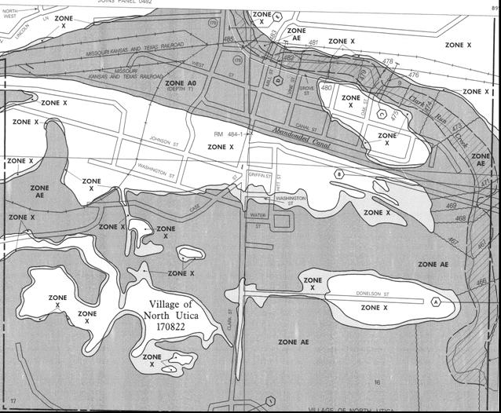  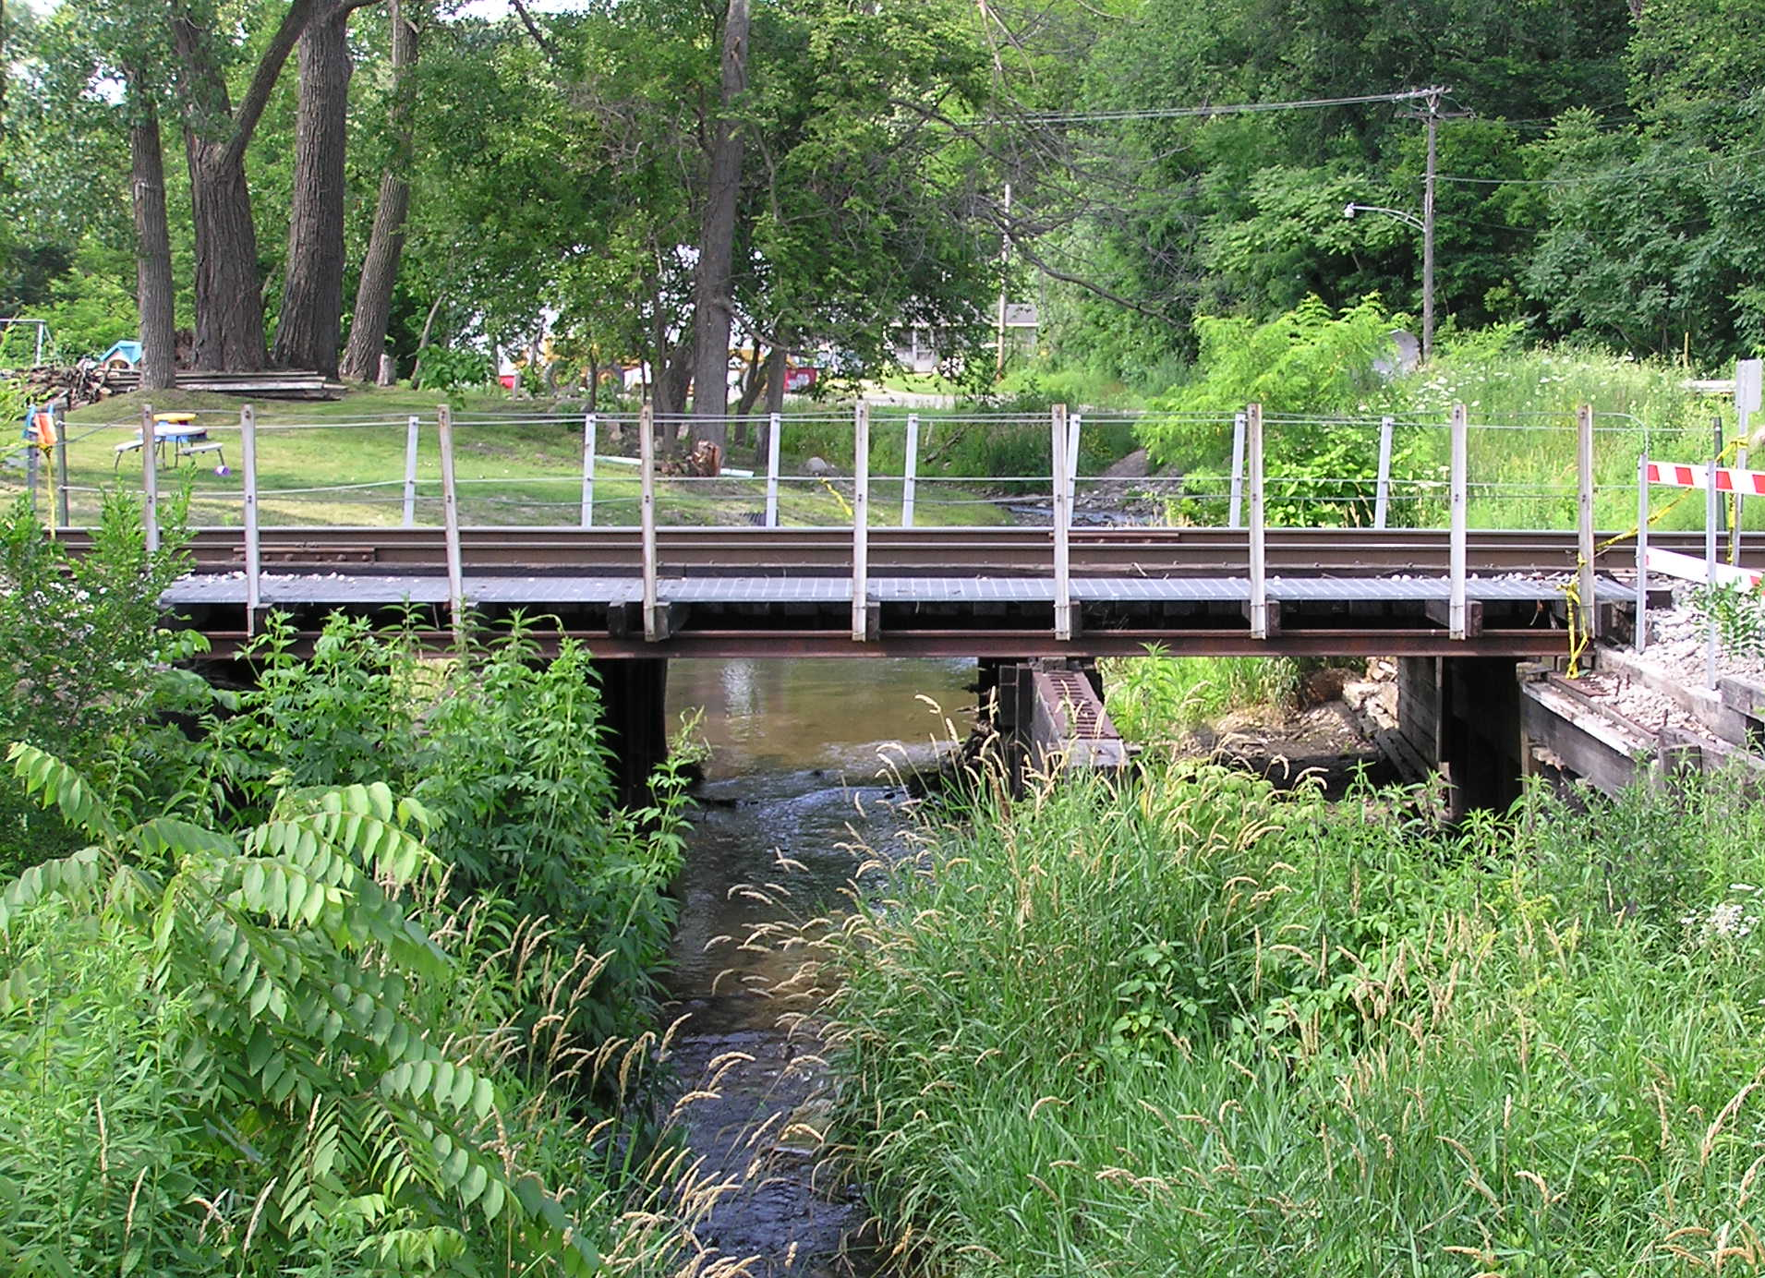  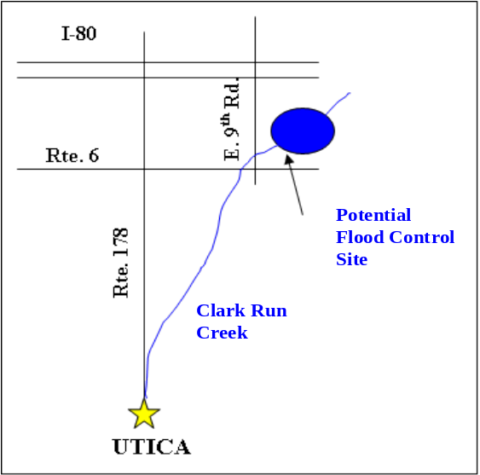  Recovery Value  HIGH  Flood map shows downtown Utica within the 100-year floodplain.  Flooding in downtown Utica is caused when Clark Run Creek overflows its banks following periods of heavy rains. | Recovery Value  Reducing the potential for flood damages in downtown Utica would alleviate economic impacts, encourage new development, and help to revitalize the downtown.  Goal  Implement a flood protection measure to reduce the risk of flooding from Clark Run Creek, in an attempt to remove the downtown portion of the community from the 100-year floodplain.  Project Description  Utica has experienced periodic flood damage ranging from annual nuisance flooding to widespread damage. A majority of the commercial development in the Village and multiple downtown municipal buildings are located in the 100-year floodplain. The impacts of recurring flood damage, along with the continuous risk of future damage, restrict the economic potential of the area. Changing the delineation of the 100-year floodplain is a complex process, and there is no easy way to immediately remove downtown from the floodplain as post-tornado rebuilding proceeds; however, long-range flood protection options do exist.  Options  Flood Control Basin on Clark Run Creek  The construction of a flood control basin on Clark Run Creek upstream of downtown Utica would limit the flow during flood events, and may reduce the flood depths in the community. Although a detailed feasibility study would be required, preliminary estimates show the basin’s normal water surface area would be at least 15 acres in size, and 100 acres in size during the 100-year flood. In addition to containing floodwaters, the basin could also be used as a recreational feature and serve as a storm water management facility to support future development. The specific location and design of the basin would be determined with careful consideration regarding the impacts on nearby natural resource areas and wildlife habitat. The project would require the acquisition of approximately 160 acres of agricultural land.  High Flow Bypass from Clark Run Creek  This project includes the construction of approximately a 5’ x 8’ box culvert from Clark Run Creek to the I&M canal. In the 100-year flood, the culvert would be designed to convey floodwaters into the canal that would typically flow overland through downtown. The culvert could run through an existing municipal right-of-way, or along the route of realigned IL-178. The inlet to the culvert would be designed to maintain base flow in the creek and only operate in high flow events. The potential for debris clogging at the inlet to the culvert may still exist following construction.
The proposed flood control basin would be located on Clark Run Creek upstream of downtown Utica.  . |  |   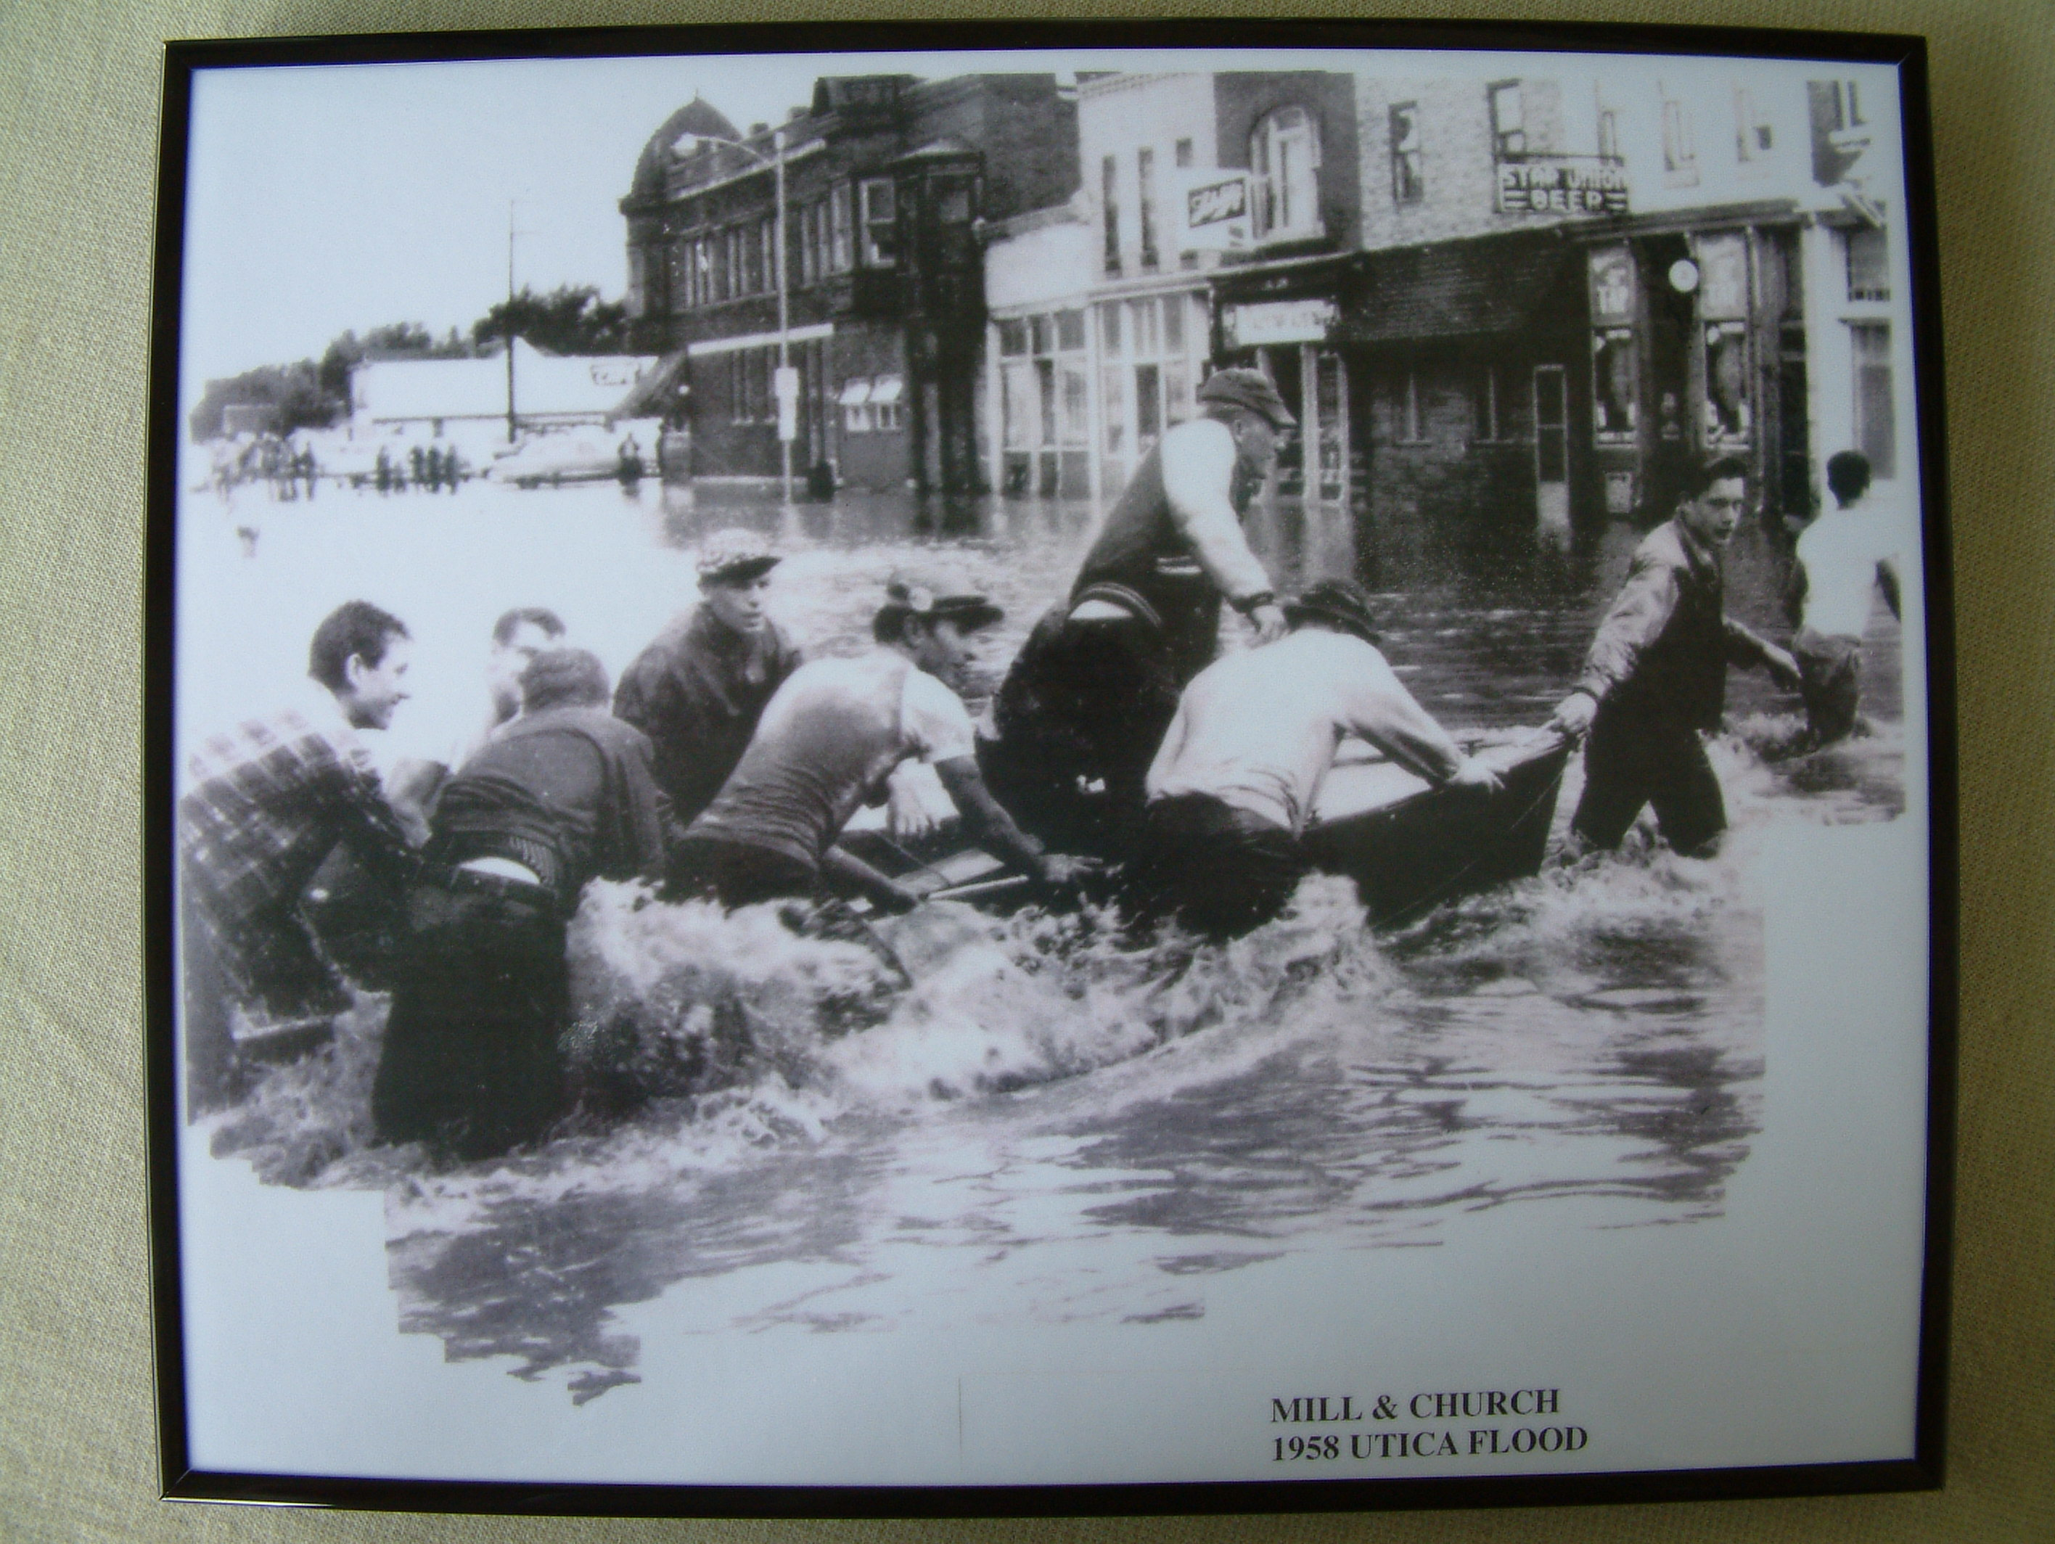  Cost  Flood Control Basin: $3.5M - $4M (160 acre land acquisition, construction of a 15-acre lake with a 100-acre flood basin, impounding approx. 580 acre feet)  High Flow Bypass: $700,000 (940LF of 5’x8’ precast box culvert constructed in the existing public right-of-way)  Multi-Purpose Building: $598,000  (Site improvement and interior finishing to pre-existing shell)

