

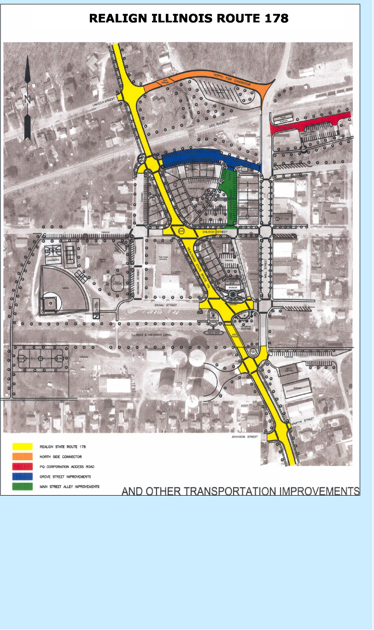
OTHER TRANSPORTATION IMPROVEMENTS
Recovery Value
A reconfigured street grid system is needed to integrate the downtown with the Illinois Route 178 realignment to encourage more visits to downtown businesses.
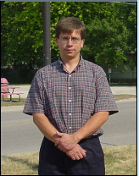
Stan Slusser PQ Corporation
“Realigning IL-178 is only one part of the
solution. These other road projects could go a long way to making it easier to get downtown. It would improve the quality of life for the citizens of Utica.”
Recovery Value
HIGH
Goal
Enhance mobility, improve the downtown business climate, increase opportunities for new development, and significantly improve the pedestrian atmosphere.

Project Description
The downtown street grid system needs to be reworked in order to complement the proposed IL-178 realignment and support land assemblage to allow for efficient development. Improving the street grid system will allow the trucks to bypass downtown while promoting more shopping visits to the downtown business district.

Options
North-Side Connector
Construct a new roadway and bridge connecting the existing IL-178 to Mill Street to provide a route for trucks to enter and exit the downtown area to the north without disrupting traffic in the heart of downtown.

PQ Corporation Access Road
Construct a new access road that would extend east from Mill Street between the Post Office and Train Station along Clark Run Creek to the PQ Corporation. The road would remove truck traffic from the residential neighborhood along the existing access route on Grove Street and improve safety conditions.
Grove Street Improvements
Upgrade West Grove Street from a one-lane, one-way road to a functional two-lane, two-way street with pull-in parking on both sides between IL-178 and Mill Street. Grove Street improvements would draw tourist traffic into the downtown area by providing an additional downtown entryway, improving overall mobility, and providing additional downtown parking.

Main Street Improvements
Upgrade and realign Main Street between Church and Grove Streets to provide a more logical street network and additional parking for future expanded development in downtown Utica. This street segment can be designed as an attractive green street and green parking area using generous landscaping and permeable pavers, blended seamlessly with the plaza and commons proposed immediately to the west. The Main Street Alley between Canal and Church will be designed primarily as a service drive and for parking access.
Cost
North-side Connector: $620,000 (incl. a 600’, 2-lane village roadway, a 60’ bridge, utilities, traffic control, landscaping, design & engineering)
PQ Access Road: $240,000 (land acquisition, pavement for 1080’ of road)
Grove/Main Street Improvements: $300,000 (land acquisition, curbs, pavement, parking)

