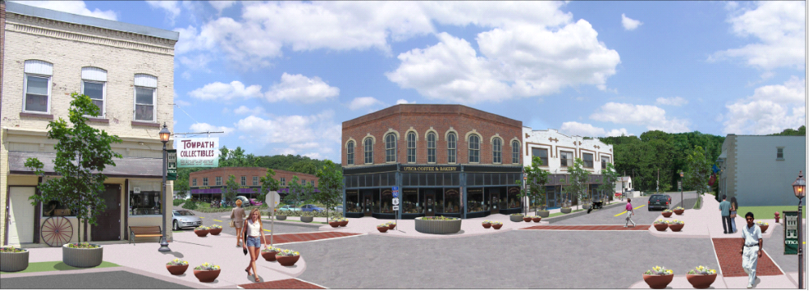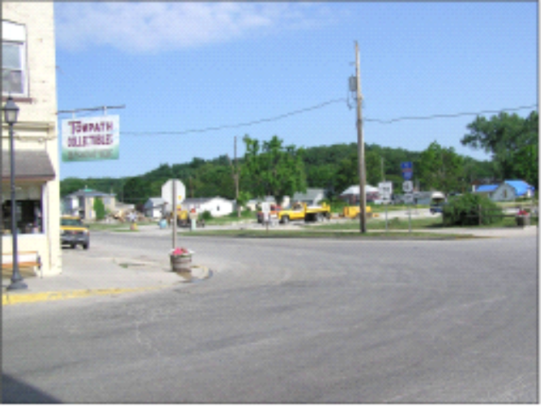
Simulation of Church and Mill Streets
These “visioneered” conceptual images of Utica are intended to present a realistic
picture of what the future Utica could look like. To produce these pictures, engineers on
the FEMA Recovery Team took post-disaster photos of the community and then used
computer visualization software to superimpose images of key proposed recovery
projects. The purpose is not to define specific land uses, promote any particular
business type, or to identify parcels of property for acquisition, but rather to provide a
general feel for how the community could develop as recovery progresses.
Church and Mill Streets post-tornado

