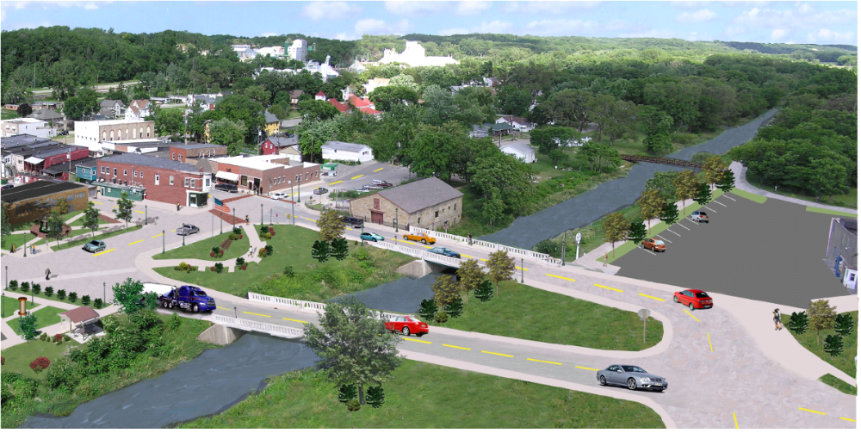
UTICA UNITED RECOVERY PLAN
Village of North Utica, IL
July 2004

